生產工廠估價單

Customer | ABC公司
DUNS#
Currency
RFQ #
RFQ Date
RFQ Response
Lead Time
Start Date

工作說明
Parts included in estimate | Supplied reference file
 | 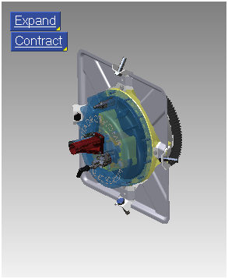

細部估價資料
Gasket | 2
Screw : Socket - M5.0 x 25.0 | 6
Screw : Socket - M5.0 x 35.0 | 2
Nozzle Holder | 1
Nozzle | 1
Honda 31cc Plug | 1
Gasket-Injector | 1
Exhaust | 1
Spark Plug | 1
Intake | 1
Main Linkage 2 | 1
Main Linkage 1 | 1
Main Linkage 4 | 1
Main Linkage 3 | 1
Hollow Pin | 4
Solid Pin 48mm | 2
Solid Pin 63mm | 2
Secondary Linkage B | 4
Secondary Linkage A | 4
Screw : Socket - M6.0 x 25.0 | 20
100BC Bearing | 2
Circlip | 2
Housing Back Plate | 1
Main Housing | 1
Screw : Socket - M8.0 x 55.0 | 12
Upper Drive Plate | 1
Bushing 48mm | 1
Screw : Socket - M6.0 x 25.0 | 6
Starter Ring | 1
Screw : Socket - M8.0 x 80.0 | 6
Lower Drive Plate | 1
Bolt : Hex - M12.0 x 45.0 | 4
Washer : Plain - M8.0 | 4
Nut : Standard - M8.0 | 4
Bolt : Hex - M8.0 x 30.0 | 4
Bracket | 4
Firewall | 1
Screen Print | 1
Housing Front Plate | 1
Air Sensor | 1
Static Axis 28x48 | 1
Central Pin | 1

Notes
- This estimate is valid for 21 days from the date of receipt.
- All costs are based on job quantities of 1,000.
- Any design changes will require a new estimate and associated quotation.
- CAD geometry files in Parasolid, ACIS, STEP and IGES are required upon acceptance of the final quotation.

